Kathy Anderson  Phone: (218) 477-6510  andersk1@fargo.k12.nd.us  www.trollwood.org | Trollwood Performing Arts School  At Bluestem Center for the Arts  801 50th Ave S  Moorhead, MN 56560
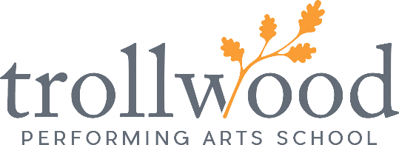

Trollwood PERFORMING ARTS SCHOOL Summer season

cancelLation Notice

For Immediate Release

April 17, 2020: After careful consideration, Trollwood Performing Arts School announces its 2020 season will be cancelled in response to the COVID-19 crisis. This includes all arts educational programming held at Bluestem Center for the Arts and other Fargo Public School locations. Programs affected by this cancellation include Trollwood Academy, Totally Trollwood Academy, Totally Trollwood Musical, Trollwood Conservatory, Mainstage Musical, ArtSpark, Trollwood Players, Trollwood Student Leadership program, and all performances of Rodgers + Hammerstein’s Cinderella, scheduled for July, 2020. This cancellation announcement is only for Trollwood programs and is not related to other events scheduled to take place at Bluestem Center for the Arts.

Many factors were considered before making this difficult decision, including the unknown length and impact of the social distancing requirements, shelter in place orders, quarantine regulations, and more. The health of its students, volunteers, staff, and audiences is of utmost priority.

Kathy Anderson, Executive Director states, “This is a heartbreaking announcement for us to make. We will miss the joyful energy our students bring to Trollwood each summer. In the future, as normalcy begins to emerge, we look forward to creating some new and exciting arts educational opportunities for our students to enjoy. Until then, our best wishes remain with those we know as our Trollwood family during this difficult time. We look forward to creating a magical summer of 2021!”

The Trollwood office will contact patrons who have purchased group sales for Cinderella with further details. All registered students will be contacted regarding registration logistics.

Further announcements will be forthcoming regarding future performances and arts educational opportunities as plans are finalized.

For further information please contact Kathy Anderson, Executive Director, at 218-477-6510 or email andersk1@fargo.k12.nd.us.

ORGANIZATION BACKGROUND. Trollwood Performing Arts School, located at Bluestem Center for the Arts, is a unique arts organization committed to providing high quality arts education, exceptional community entertainment, and serves as a community events and exposition center. The TPAS mission is “...to inspire those we serve through the arts to realize their full potential and be a positive influence in the global community.” Founded in 1978, Trollwood is a program of the Fargo Public Schools.

